
RAMAIAH
INSTITUTE OF TECHNOLOGY
USN | 1 | M | S

(Autonomous Institute, Affiliated to VTU)
(Approved by AICTE, New Delhi & Govt. of Karnataka) Accredited by NBA & NAAC with ‘A’ Grade

MAKEUP EXAMINATIONS – FEBRUARY 2018

Course & Branch | : | B.E. : Common to all branches | Semester | : | I/II
Subject | : | Basic Civil Engineering and Mechanics | Max. Marks | : | 100
Subject Code | : | CV101 / CV201 | Duration | : | 3 Hrs

Instructions to the Candidates:
- Answer one full question from each unit.
- Assume missing data suitably.
- Draw sketches wherever necessary.

 |  | UNIT- I
1. | a) | Define Civil Engineering and explain its scope. | CO1 | (10)
 | b) | Discuss the role of a Civil Engineer in the development of a country. | CO1 | (10)
2. | a) | Write a note on the impact of infrastructural development on the economy of a country. | CO1 | (08)
 | b) | What are the uses of:  i) bricks ii) timber iii) RCC iv) PSC. | CO1 | (12)
 |  | UNIT- II
3. | a) | Differentiate the following terms.  i. Concurrent and non concurrent. ii. Equilibrant and Resultant. | CO2 | (08)
 | b) | Define force. Explain classification of system of forces. | CO2 | (07)
 | c) | An electric transmission tower supports two cables carrying tension of 180 KN and 200 KN. Determine the required tension in the given wire AB. SO, that the resultant of the forces exerted by three cables will be vertical. Also find the magnitude of resultant for fig.3(c)  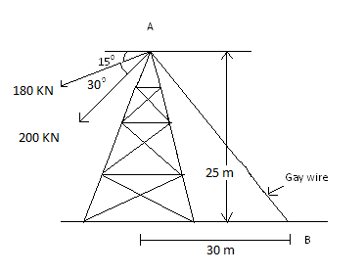  Fig.3(c) | CO2 | (05)
4. | a) | Explain couple and its characteristics? | CO2 | (05)
 | b) | State and prove Varignons theorem of moments? | CO2 | (07)
 | c) | Determine the magnitude, direction and distance of the resultant from the point ‘A’ for the system of forces shown in Fig. 4(c)  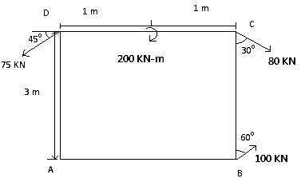  Fig.4(c) | CO2 | (08)
 |  | UNIT- III
5. | a) | Explain types of supports and loads with sketches. | CO2 | (06)
 | b) | Explain types of supports and loads with sketches. Find the support reactions of beam loaded as shown in Fig. 5(b).  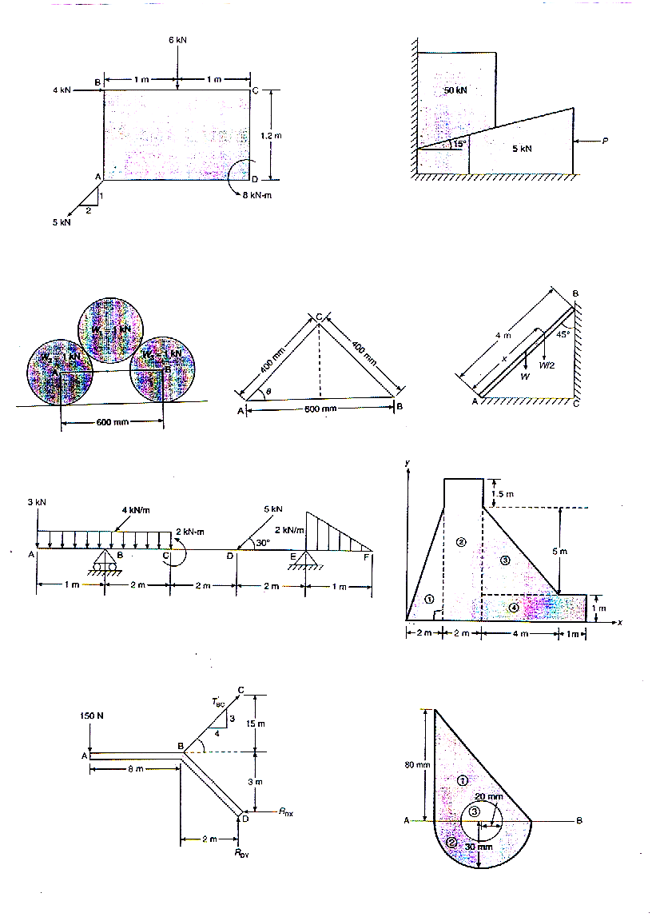  Fig. 5(b) | CO2 | (14)
6. | a) | Explain types of beams with sketches. | CO2 | (08)
 | b) | Calculate the tension in strings BC and reaction at the hinged support for beam ABD in equilibrium, shown in Fig. 6(b).  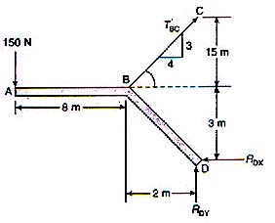  Fig. 6(b) | CO2 | (12)
 |  | UNIT- IV
7. | a) | Provide brief explanation about the following:  - Centroid  - Centre of gravity  - Axes of reference  - Polar moment of inertia  - Radius of gyration. | CO4 | (10)
 | b) | Determine the least radius of gyration of the unsymmetrical section shown in Fig. 7(b).  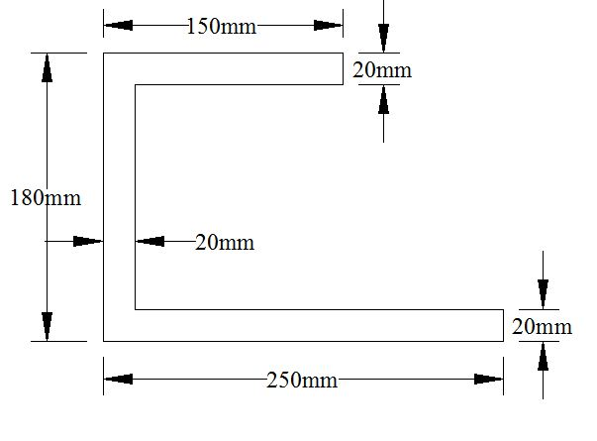  Fig. 7(b) | CO4 | (10)
8. | a) | Arrive at the centroid of a rectangular lamina with the help of neat sketch. State parallel axis theorem and prove the same. | CO4 | (10)
 | b) | Determine the centroid of the hatched portion shown in Fig. 8(b) representing cross section of a dam.  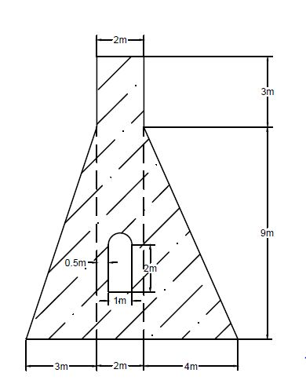  Fig.8(b) | CO4 | (10)
 |  | UNIT- V
9. | a) | Explain the following:  - limiting friction ii) Angle of fiction iii) Angle of repose. | CO5 | (10)
 | b) | Determine the necessary force P acting parallel to the plane in order to cause motion to impend. Take µ = 0.25. as in fig.9(b)  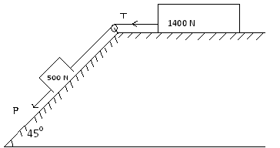  Fig.9(b) | CO5 | (10)
10. | a) | State the laws of static friction. | CO5 | (05)
 | b) | A uniform ladder 4m in length rests against a vertical wall with which it makes an angle of 45. Take coefficient of friction between the ladder and the wall is 0.40 and that between the ladder and the floor is 0.5. If the man whose weight is one-half of that of ladder ascends it, how high will it be when the ladder slips? (as in fig.10(b))  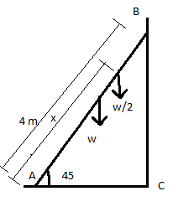  Fig.10(b) | CO5 | (10)
 | c) | Distinguish between ladder friction and wedge friction. | CO5 | (05)

****************

